|  |
| --- |
| Close-up image showing the leaf-sides of two oversized books side-by-side on a bookshelf, with additional books in soft focus background |
| UI/UX Design of an E-Commerce Website using Adobe Photoshop CC.  Students:   1. Bilal Ahmed Khan (20k-0183) 2. Zulnoor Siddiqui (20k-1090) 3. Mohammad Wamiq Akram (20k-1857) |
| |  |  |  | | --- | --- | --- | |  |  |  | |

1. **Making the Outline of the webpage:**

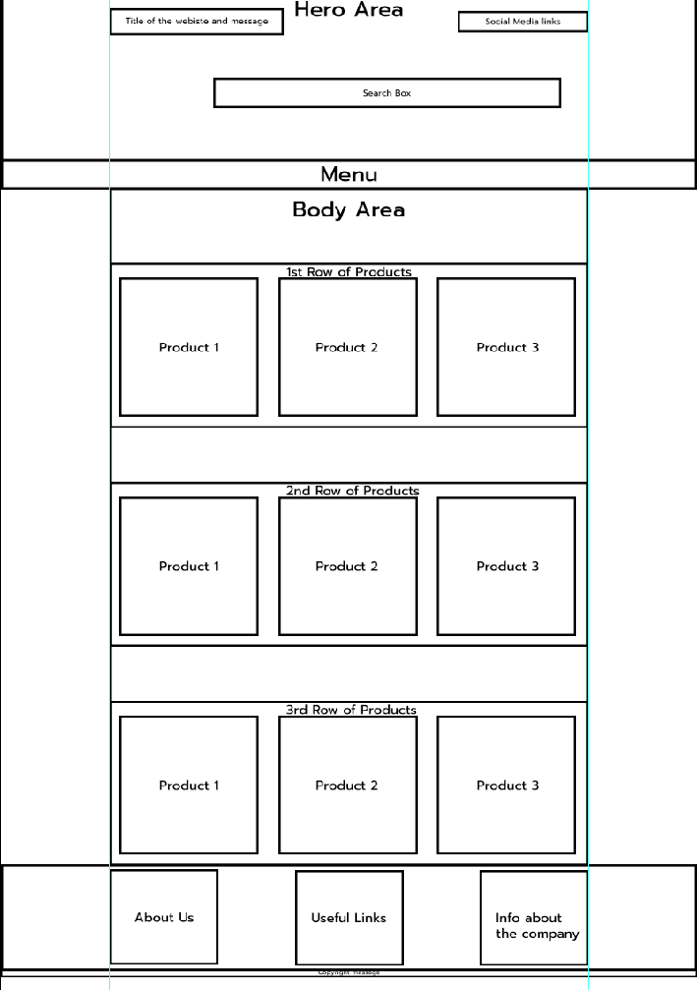

**Tools used in making the outline:**

1. Rectangle Tool
2. Rectangular Marquee tool (For Selection Purposes)
3. Move Tool (For accurate placement of each element)

**Procedure:**

Yaha tum logo ne ye likhna hai k ye dabbe bana bana ke ham ne coherently aik saath lagaye hein taake saare design mei uniformiy rahe.

1. **The Header of the webpage:**

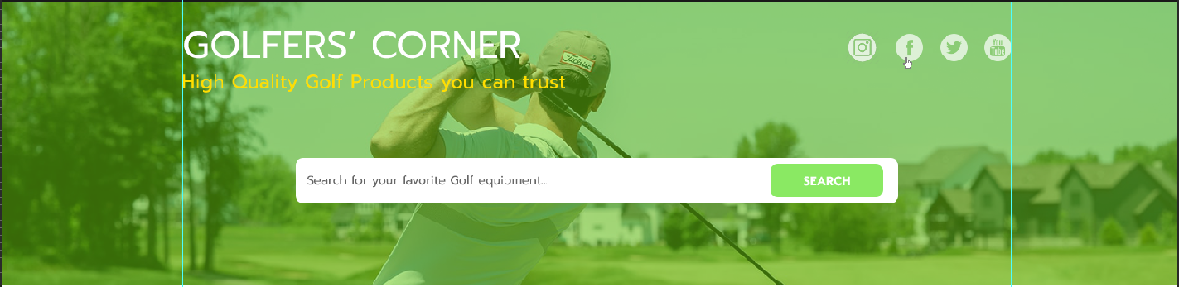

**Tools Used:**

1. Rectangle Tool
2. Rectangular Marquee tool (For Selection Purposes)
3. Move Tool (For accurate placement of each element)
4. Layers Panel for editing the opacity of the background image
5. Character panel for selecting font and managing typography

**Procedure:**

Yaha ye likhna ke hamne sab se pehle aik background rectangle banaya

Uss pe aik image unsplash.com se utha ke “Clipping mask” attach kar di or uski

opacity down kar di jis se “color overlay” ka effect aya hai.

1. **Menu of the webpage:**

**Tools Used:**

1. Horizontal type tool
2. Character panel

**Procedure:**

Yaha pe ye likhna hai k ham ne sab se pehle aik background rectangle banaya or uss ke bad ham ne menu items ke name type kiye or jo current menu item selected hai usko show karne k liye ham ne uska color, color theme ke hisab se set kya hai.

1. **Product Box:**

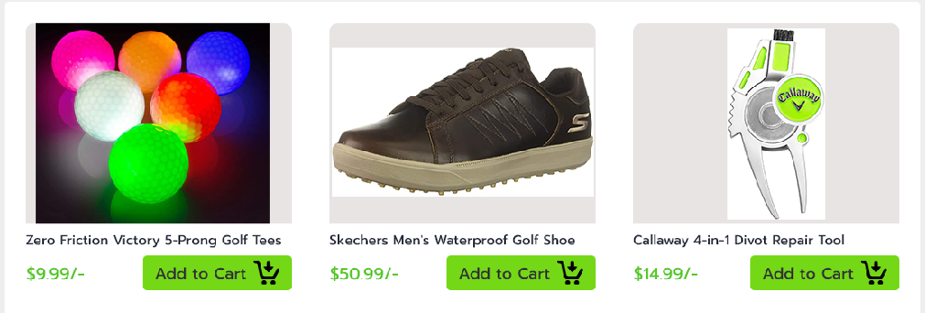

**Tools Used:**

1. Rectangle Tool (For making Add to Cart button)
2. Rectangular Marquee tool (For Selection Purposes)
3. Move Tool (For accurate placement of each element)
4. Layers Panel stacking the layers in orderly manner on each other
5. Character panel managing typography
6. Clipping masks for joining the picture of the product to the background triangle

**Procedure:**

Yahi sab se pehle ye likhna hai ke ham ne aik background triangle banaya or uss ke bad product ki image uss se clipping mask ke zariye ham ne attach kar di. Phir ham ne Type Tool use kar ke uski price wagera likha or “Character panel” se uski typography manage ki. Uske bad ham ne Rectangle tool ke zariye “Add to Cart” ka “Call to action” button banaya.

Or bas phir uske bad ham ne aik product box bana ke baki replicate kar diye.

1. **Bottom of the webpage:**

**Tools Used:**

1. Move Tool (For accurate placement of each element)
2. Character panel for managing the line spacing and other elements of the typography
3. Rectangle Tool (For making the background rectangle)

**Procedure:**

Yaha bs ye likhdo ke ham ne bottom ko 3 section banaye hein

1. About Us
2. Important links
3. Info about the company

Or bas iske bad aap ne ye likhna hai k Ham ye Horizontal type tool se iss section mei text enter kya. “Character panel” se “typography” manage ki or uske bad “Move Tool” se saare elements accurately arrange kar dye or bas.

**And after all the elements of the webpage have been completed the final form is as follows:**

